- Installing the OS and Vbox set up
  - download oracle or any Vbox
  - go to https://www.raspberrypi.com/software/operating-systems/ go to the bottom of the page you want the raspberry pi desktop os it’s the only one that works for mac n windows it’s going to take a while to download
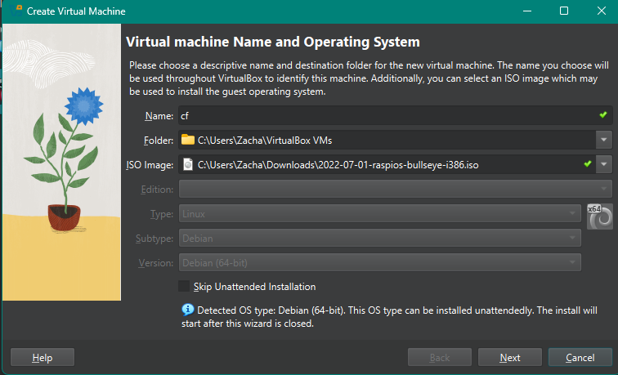
  - go into oracle and click new give it a random name and make sure the ISO file is in your downloads, and the iso file should be 2022-07-01-raspios-bullseye-i386.iso

  - allocate whatever you want for storage n ram

  - just make all the credentials “admin” need this for later
  - boot it and it will eventually take you the os screen do not click the first option you want to click install

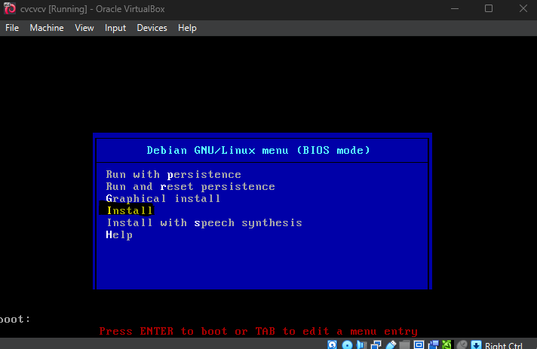
  - once you actually get into the os you will have to apt install all the libraries that are in the read me to get the fluke_gui to work also you have to run sudo every time you run the fluke_gui.pi bc of the packet sniffing

- getting either winscp working or just normal sftp working
  - first thing is the most important for some reason you have to switch your network adapter from NAT to bridged so it just runs directly off of your network card (yes the default is still eth0 for so the code doesn’t get messed up dw)
    - click on the ras instillation in oracle and click settings its right next to add, scroll down to net work and click on “attached to” and change it to bridged
this damn ss did not want to cooperate with me

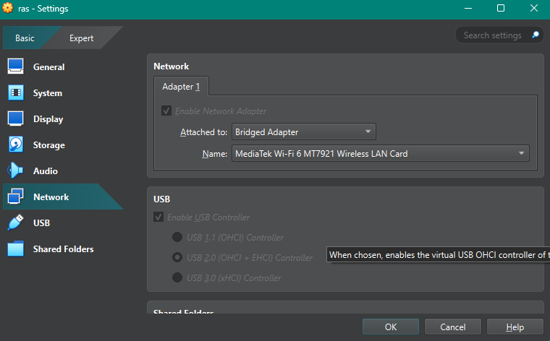

- c
  - next you gotta turn on SSH in the vm
    - click on the raspberry icon in the top left of the home screen
    - go to preferences => raspberry pi configuration => interfaces and turn ssh on
  - next go to the terminal and run “ifconfig” you want the highlighted IP if you are doing just sftp through the command line you just need to do ex: admin@169.254.7.46 (do whatever urs says obviously)
  - im gonna assume you guys know how to use sftp through the command line tbh

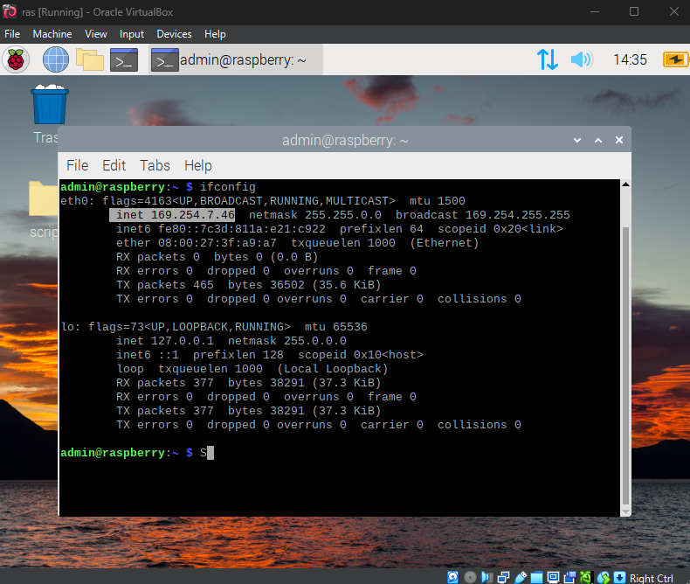
- winscp if you don’t know how to use stfp through cmd
  - download winscp
  - open it
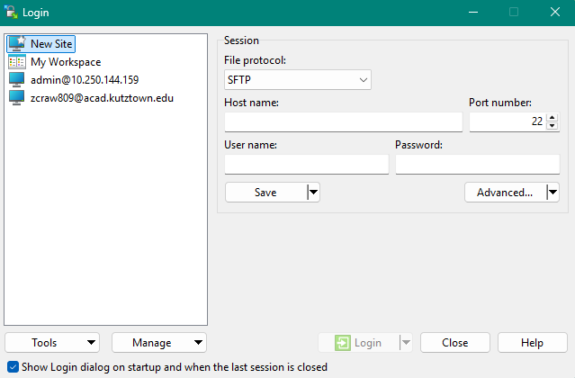
  - your gonna get prompted with this

  - put in the host name as admin@169.254.7.46 (Example) make sure the port number is 22 and put “admin” as the user name and pass and it should work

